Assignment # 3

Syed Maaz Anwer (9360) (leader), [maaz.iunc@gmail.com](mailto:maaz.iunc@gmail.com)

Muhammad Sannan (12395), [msannan40@gmail.com](mailto:msannan40@gmail.com)

Nabeel Ahmed (13839), [nabeelahmedahmed9@gmail.com](mailto:nabeelahmedahmed9@gmail.com)

Mirza Shahmeer Baig (10241), [Mirzashahmeer96@gmail.com](mailto:Mirzashahmeer96@gmail.com)

This assignment # 3 pertains to the requirement analysis and usability phases of your project.

For the project that you have selected in earlier phase, you are required to do

**Phase3: Requirement Analysis**

1. Define all the functional and non-functional requirements of your project.

**Functional Requirements**

* The login page is outside of the secure area of the system and allows the user (customer) to log onto the web application. The user can view the store and add their order to shopping cart but only the members can proceed to checkout however, super admin and other admins can register new members as well. For login functions, there is an area to input the username (full name) and password for the account protection of the registered users, password will be encrypted upon saving into database. In case the user members forgot their password the system provides the link to reset the password which will be sent only to members.
* Each individual can see the store online, but as it were the individuals can checkout it gotten to be control by admin. For being part of site, the client have to be enlist for enrollment.
* Authentication of user whenever he/she logs into the system.
* The client can browse and look the thing and include to the shopping cart and can checkout conjointly the client can alter profile that incorporates alter shipping address and subtle elements. For other data to be changed
* Client will be able to see his/her orders history. Each client must be able to see put arrange status. Client ought to be able to approve and ratify their receipt.
* The client will be given a web interface which permits simple browsing through the distinctive rooms. Basically the things within the shop are well organized and well displayed so that a client can discover his enquire thing effectively.
* This portal will keep the record of the daily sell.
* It will store the feedback given by the customer.
* It will provide keeping details about the product it is delivered or not etc.
* Storing the items selected by the customer in the Temporary storage.

**Administrator control page**

In online shopping portal the admin can edit the catalog details, and also can add new items can delete items, can change price can see feedback. The system can push notification to every member of online store.

* **User administration**this includes registration processing, user deactivation, user suspicious and required password change.
* **Website statistics**  
  this includes number of users, usage reports, upload reports, download reports, and performance metrics. One of the most important thing in this web base systems is the security especially for online shopping and the protection of the asset from hackers and attackers.

**Non Functional Requirements**

* **Fast response time for user login**  
  the average response time for user login after entering user name and password is  
  no more than 3 sec and the maximum response time is 10 seconds.
* **Fast average time for rendering a page**  
  after clicking on any link the result should be rendered within no more than 1 second in  
  average and it is not take more than 10 seconds in maximum.
* **Minimum number of concurrent users**the application is able to address at least 600 users concurrently.
* **Security**

In electronic commerce, security is a core issue that must be considered. Viruses and hacking are threatening e-commerce, thus requiring the network to provide a security solution. Including encryption, signature scheme, distributed security management, access control, secure web servers. The security of network system is divided into data security, information security and network security.

1. There will be a secure access of confidential data (customer’s details).
2. This portal will be 24 x 7 available.
3. This portal is design on better component design to get better performance
4. Flexible service based architecture will be highly desirable for future extension
5. It arise through user needs, because of budget cconstraint’s or organizational policies, or due to the external factors such as safety regulations, privacy registration and so on.
6. Develop complete use case diagram and define use cases with narratives.

**Online Shopping**

**UML Use Case Narratives**

Web Customer actor uses a few web location to create buys online. Best level use cases are View Items, Make Purchase and Client Register. View Items case may well by client as best level case in the event that client as it were needs to discover and see a few items. This case may too bed as a portion of Make Purchase case. Client Register use case permits client to enlist on the net location, for illustration to induce a few coupons or be welcomed to private deals. Note, that Checkout use case is included case not accessible by itself - checkout is portion of making purchase. Except for the Web Customer actor there are a few other performing artists which can be depicted underneath with point by point cases.

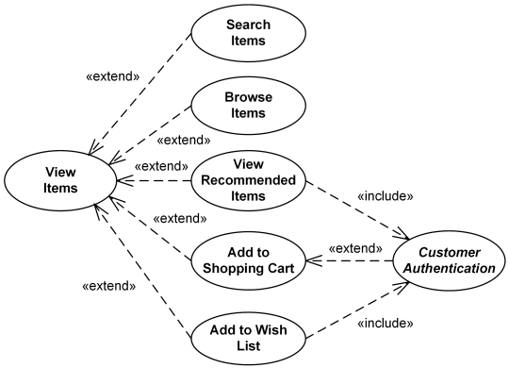

View Items use case is [extended](https://www.uml-diagrams.org/use-case-extend.html) by several optional use cases - customer may search for items, browse catalog, view items recommended for him/her, add items to shopping cart or wish list. All these use cases are extending use cases because they provide some optional functions allowing customer to find item.

Customer Authentication use case is [included](https://www.uml-diagrams.org/use-case-include.html) in View Recommended Items and Add to Wish List because both require the customer to be authenticated. At the same time, item could be added to the shopping cart without user authentication.

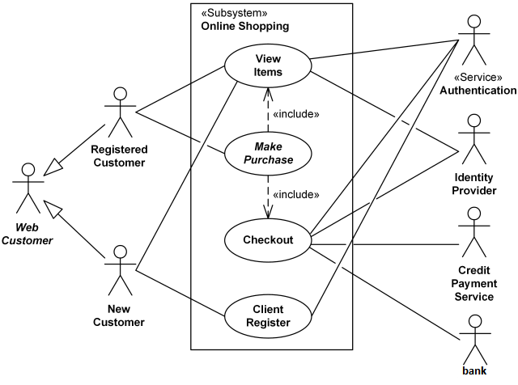

.

**Online shopping UML use case diagram (main use case)**

See Items use case is extended by a few discretionary cases - client may seek for things, browse catalog, see things prescribed for him/her, and include things to shopping cart or wish list. All these cases are expanding cases since they give a few discretionary capacities permitting client to discover item. Customer Authentication use case is included in View Prescribed Items and Add to Wish List because both require the customer to be confirmed. At the same time, thing may be included to the shopping cart without client verification.



1. Finally, you need to develop an ERD/data flow or sequence diagram, whichever suits your project.

PS: All database projects should opt for and develop ERD diagram.

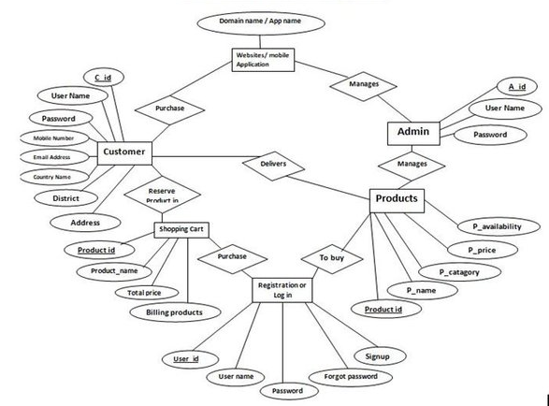

**Phase 4: Usability**

1. Design the user interface using paper prototype and wireframes for your project. Follow all the rules that are discussed in the lecture.

* **PAPER PROTOTYPE**

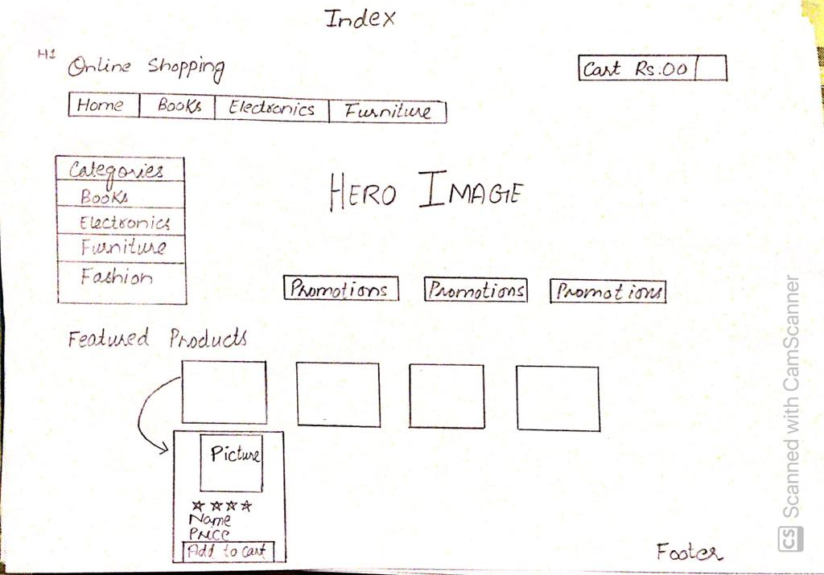

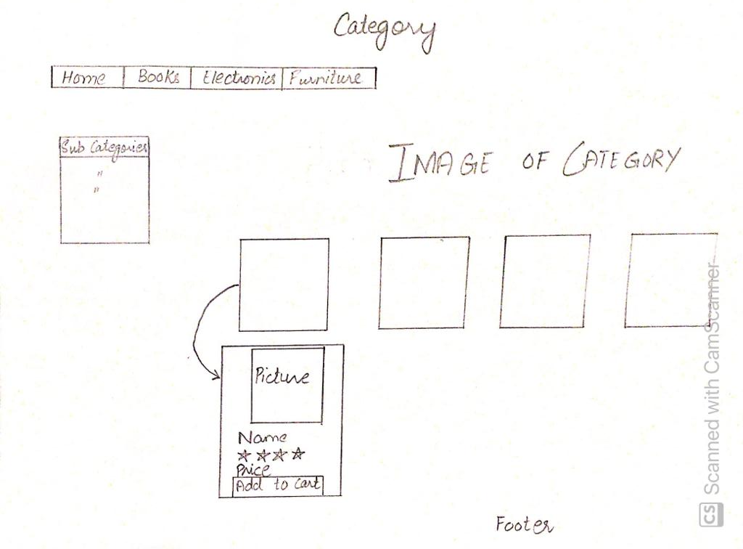

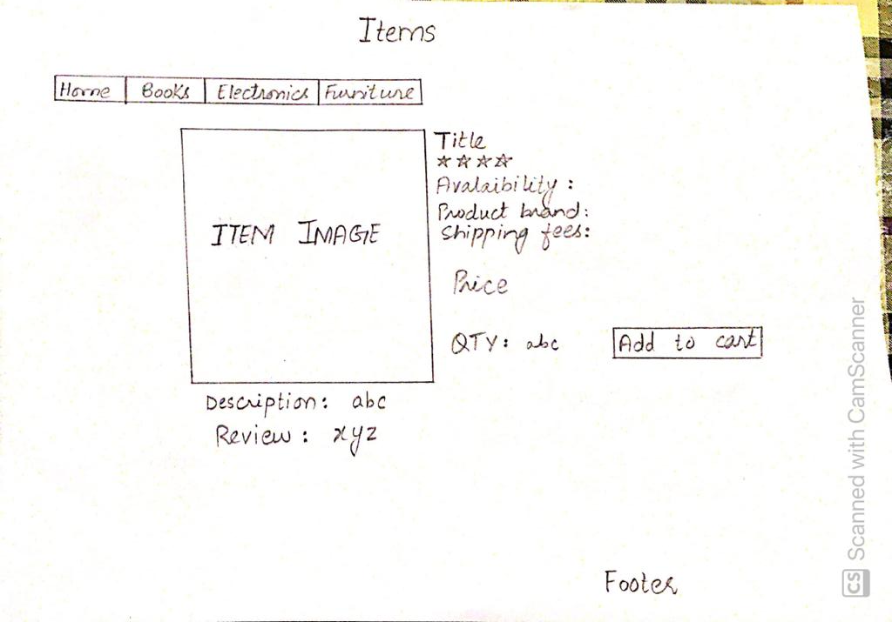

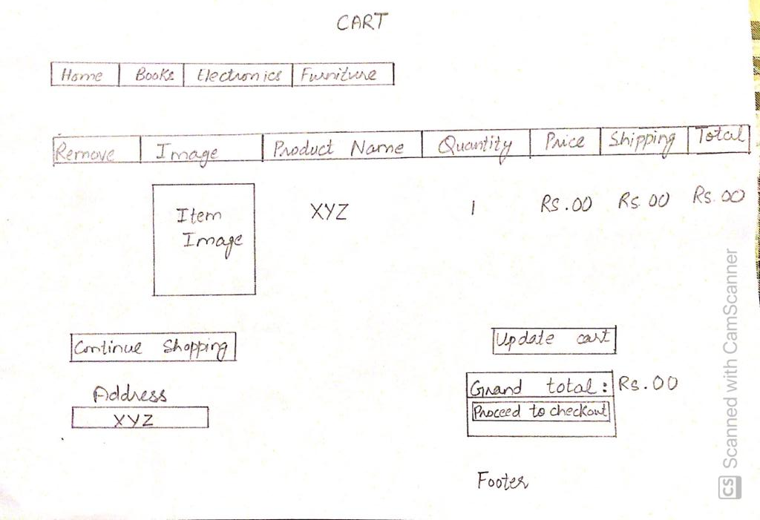

* **WIREFRAMES**

**HOME PAGE**

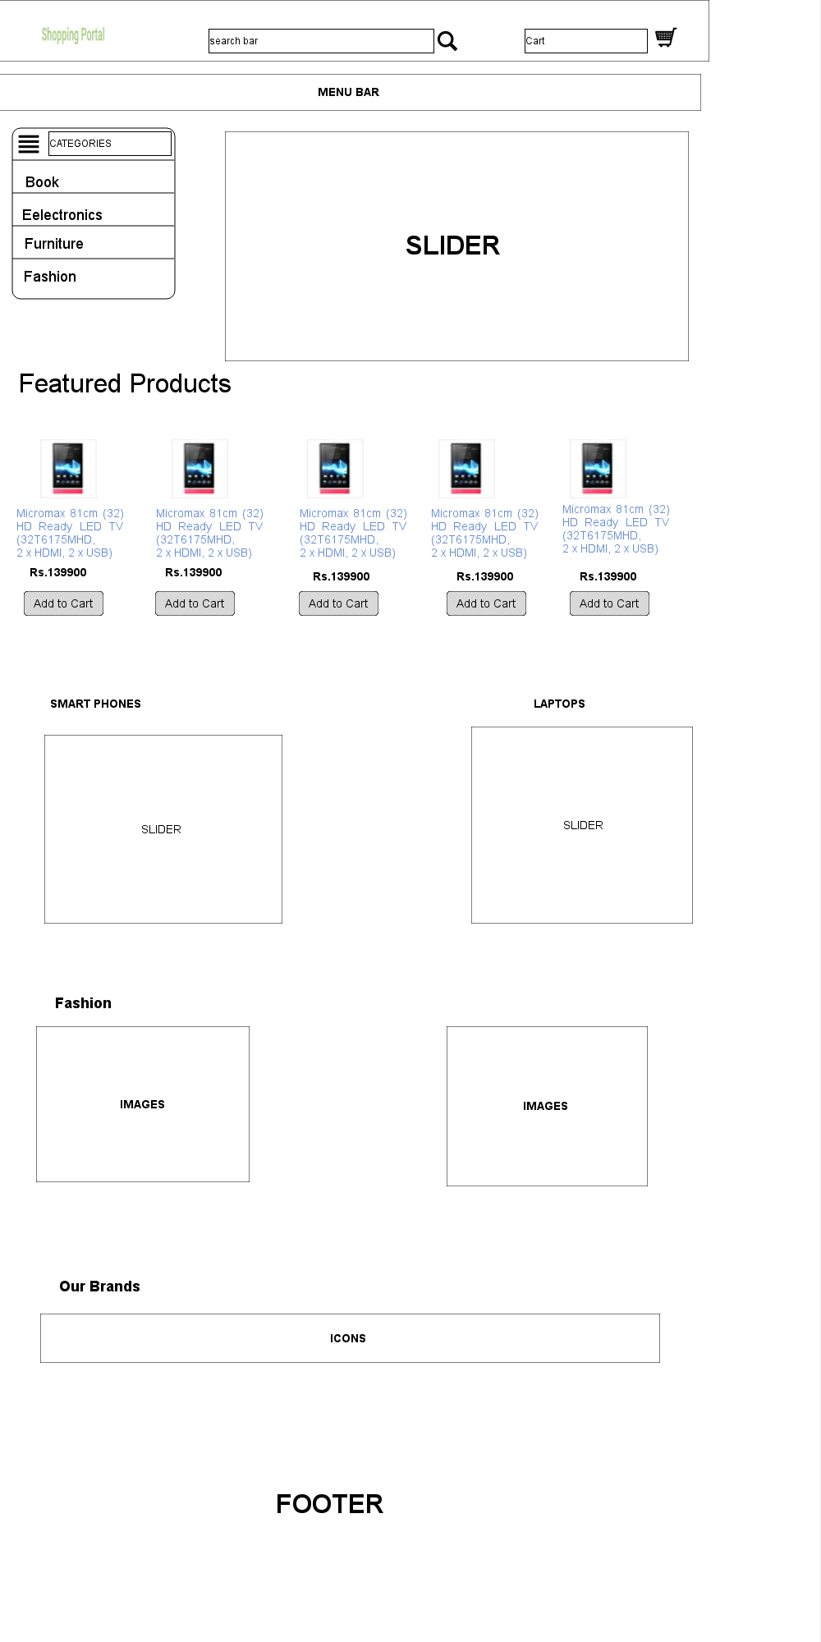

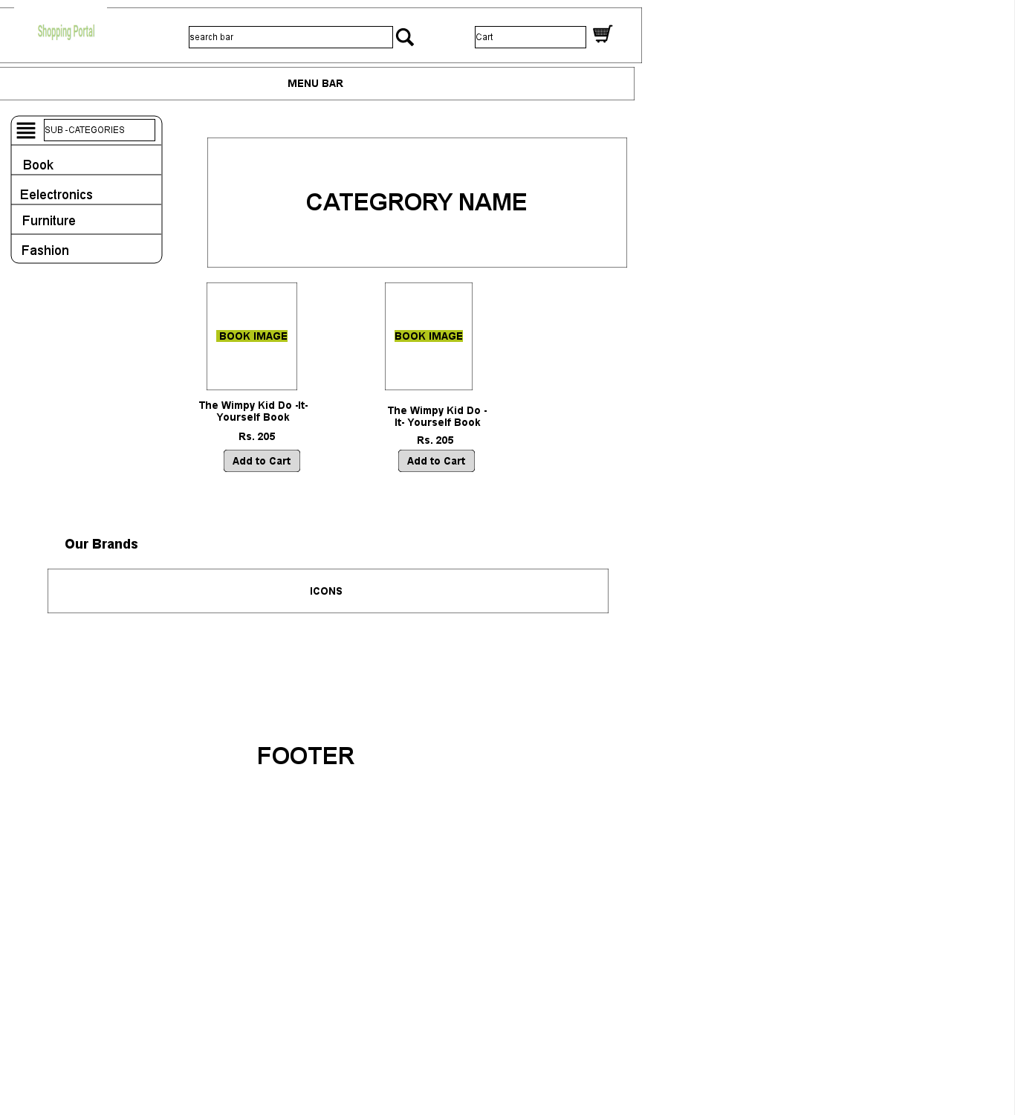 **BOOK PAGE**

**ELECTRONICS PAGE**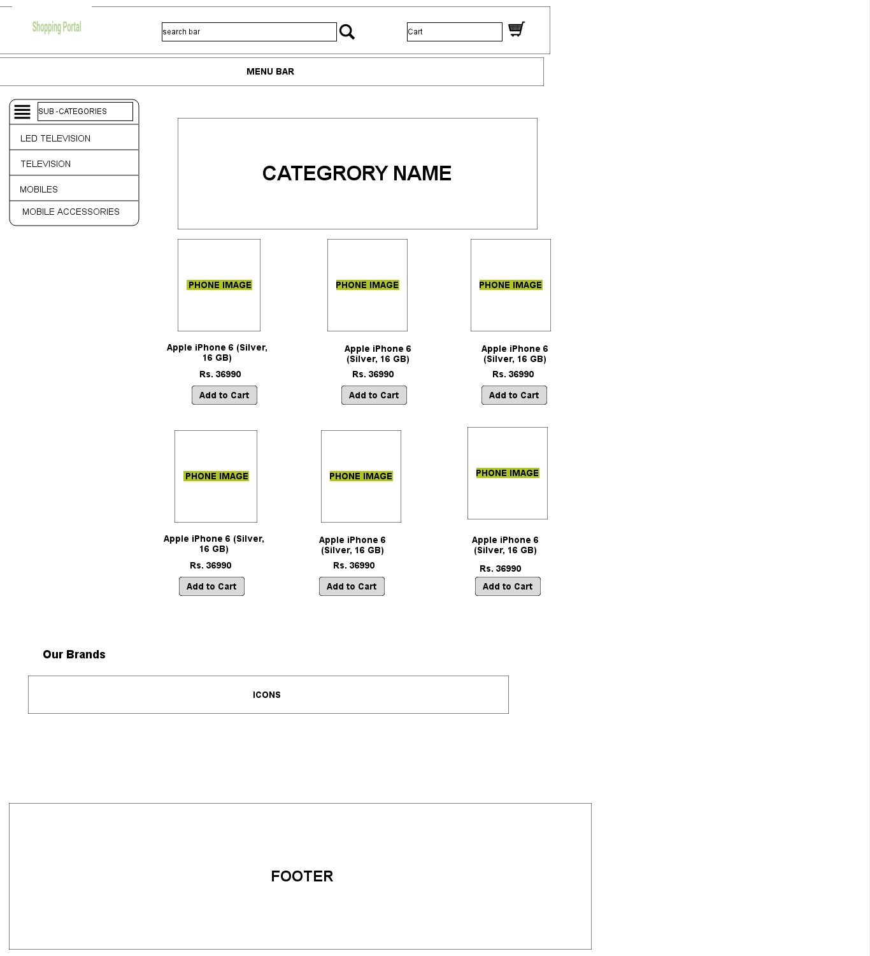

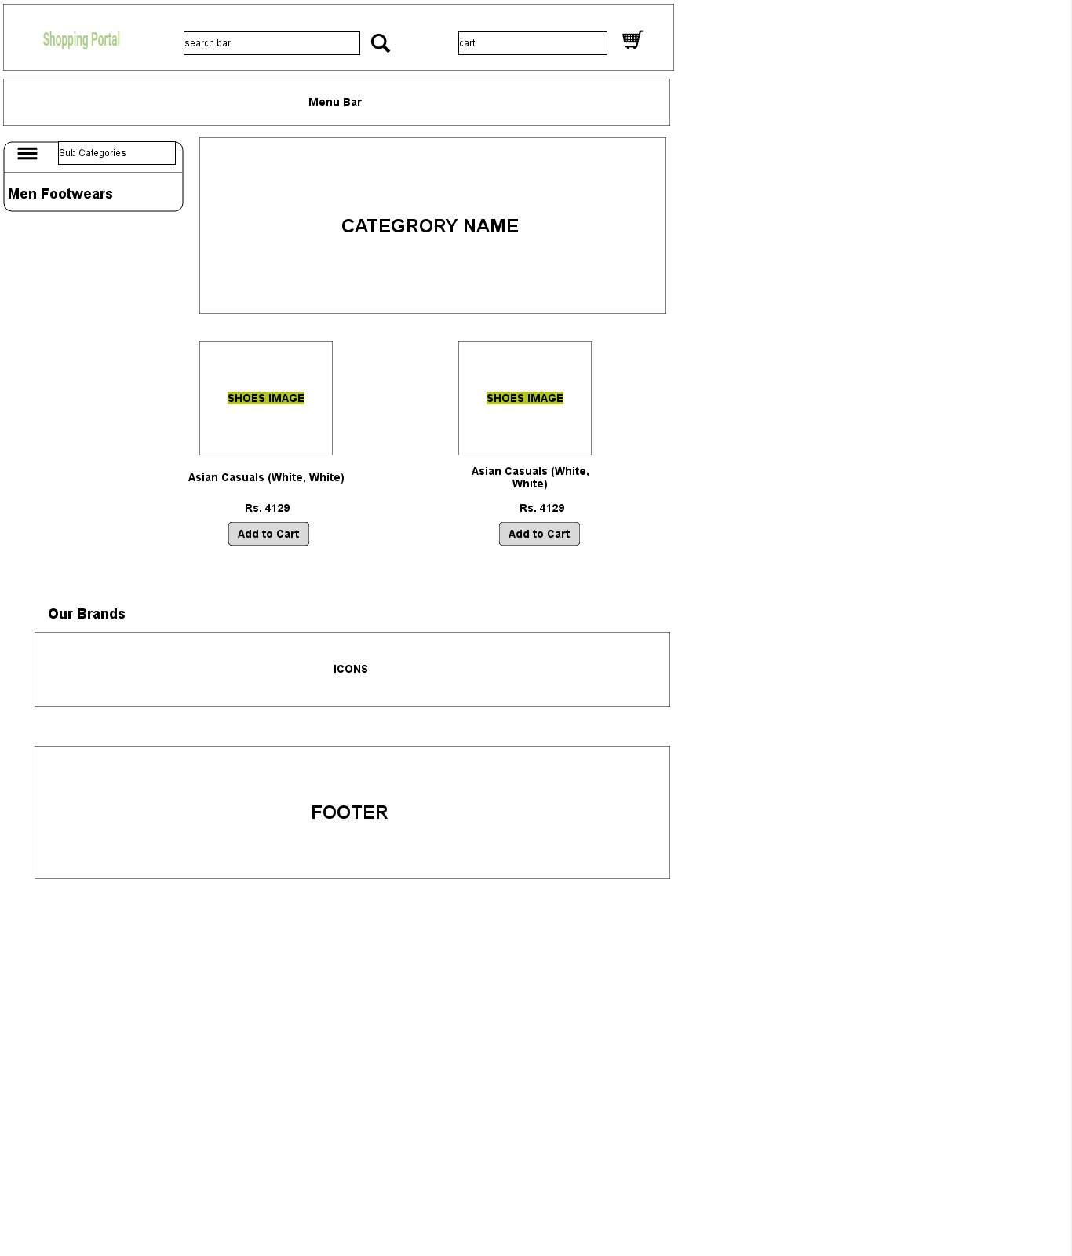**FASHION PAGE**

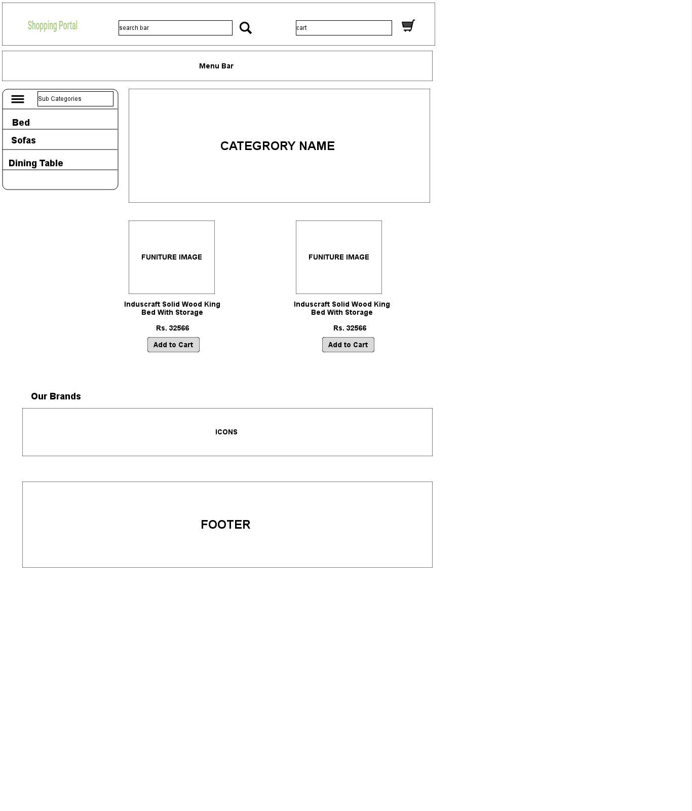**FUNITURE PAGE**

**CART PAGE**

